A Q-learning-based Snake reinforcement learning game
Youtube:
Github:

1 Introduction
This project implements a classic Snake grid game and uses Q-learning reinforcement learning to train an agent to achieve the goal of "eating food and surviving as long as possible." The game takes place on a fixed-size 2D grid. The snake moves to change its position; if it eats food, it grows longer and receives a reward; if it hits a wall or itself, the game ends and it receives a penalty.
To meet the assignment requirements, this project provides:
A complete and runnable game environment (discrete states, discrete actions, explicit reward function, termination condition)
The Q-learning training process (epsilon-greedy exploration, learning rate, discount factor, Q-table update)
A visual UI (rendered using pygame) that displays the current game state, actions, and rewards/penalties
Training logs and demo output (train_log.csv, q_table.csv, snake_demo.gif/mp4)

2 Game Design

2.1 Rules of the Game
The game map is an N×N grid (N=12 by default in this project, but can be adjusted).
The snake consists of several consecutive grids, with an initial length of 3 and one direction of movement (up/right/down/left).
Each step, the snake changes direction and moves forward one grid:
If the new head position coincides with a wall boundary or the snake's body, it is considered dead and the game ends.
If the new head position coincides with food, it eats the food, its length increases by 1 (the tail is not removed), and new food is refreshed.
If it does not eat any food, the snake moves forward normally (the head is added, and the tail is removed).
To avoid infinite loops, each episode has a maximum number of steps, max_steps, which will force termination upon reaching the maximum.

2.2 Termination conditions
An episode terminates in any of the following ways:
1) It hits a wall;
2) It hits itself;
3) It reaches the maximum number of steps, max_steps.

3 State, Action, and Reward Design
Q-learning is suitable for discrete state spaces. Since "the whole snake's coordinates" would lead to an explosion of the state space, this project uses feature-based discrete state representations to reduce the learning difficulty and retain key decision information.

3.1 State
Define the state as a discrete tuple:
danger_ahead: Is there danger ahead (colliding with a wall or hitting a body)? {0,1}
danger_left: Is there danger to the left? {0,1}
danger_right: Is there danger to the right? {0,1}
food_dir_x: Food relative to the snake's head in the horizontal direction: Left (-1) / Same column (0) / Right (1)
food_dir_y: Food relative to the snake's head in the vertical direction: Up (-1) / Same row (0) / Down (1)
current_dir: Current orientation {UP, RIGHT, DOWN, LEFT} (4 possibilities)
Therefore, the state is:
S = (danger_ahead, danger_left, danger_right, food_dir_x, food_dir_y, current_dir).

3.2 Action
The actions use relative actions (more in line with the snake's movement constraints), and there are 3 in total:
TURN_LEFT: Turn left relative to the current direction
STRAIGHT: Maintain direction and move straight
TURN_RIGHT: Turn right relative to the current direction

3.3 Reward
The reward function is designed as follows:
Eating food: +1.0
Death (colliding with a wall/colliding with oneself): -1.0 (and termination)
Each step taken: -0.01 (encourages finding food faster and reduces pointless movement)

4 Q-learning method (Reinforcement Learning Method)
This project uses Q-learning to update the Q-table Q(s,a) and employs an epsilon-greedy strategy to balance exploration and exploitation.

4.1 epsilon-greedy strategy
Explore actions randomly with probability ε, and select the action with the highest value from the current Q-table with probability 1-ε. During training, ε gradually decays:
ε ← max(ε_min, ε × ε_decay)

4.2 epsilon-greedy strategy
After each interaction, updates are performed according to the following rules:
Q(s,a)←Q(s,a)+α(r+γa′max​Q(s′,a′)−Q(s,a))
Where α is the learning rate and γ is the discount factor.

4.2 Training settings
Grid size: 12×12
Episodes: 4000
α (learning rate): 0.2
γ (discount factor): 0.9
Initial ε: 1.0, ε_min: 0.05, ε_decay: 0.997
Max_steps: 500

5 UI Visualization and Presentation
This project uses pygame to draw the mesh, snake body, and food, and displays the following information in the interface:
Current Steps
Current Direction (Dir)
Current Action (Action)
Current Instant Reward (Reward)
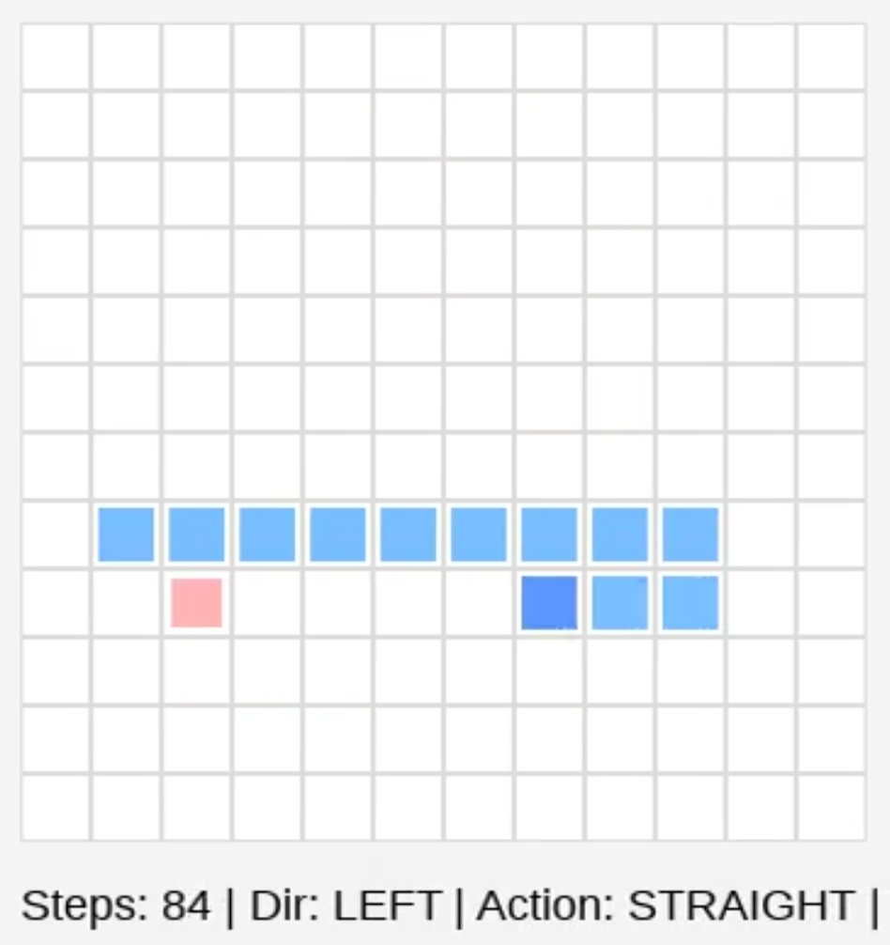
Fig 5.1 pygame UI display
Figure 5.1 shows the pygame UI. The interface displays the real-time positions of the snake and food, and shows the number of steps, direction, action, and immediate reward in the information bar to demonstrate the agent's decision-making and reward feedback.

6 Results
During training, the total reward, steps, and food score for each episode are recorded and saved as train_log.csv. The resulting Q-table is saved as q_table.csv.
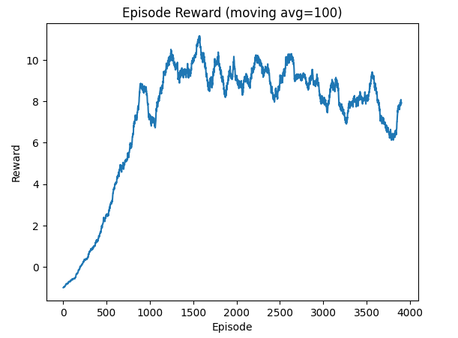
Fig 6.1 The moving average curve of the total reward for each episode during training (window=100).
Figure 6.1 shows the moving average curve of the total reward for each episode during training (window=100). The curve tends to stabilize in the later stages of training, indicating that the agent gradually reduces ineffective moves and lowers the death frequency.

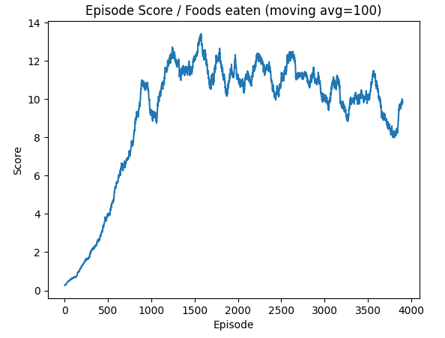
Fig 6.2 Training score curve
Figure 6.2 shows the moving average curve of the number of food items (score) eaten in each episode during training (window=100). The overall improvement in the curve indicates that the agent gradually learns to approach food more effectively and obtain positive rewards.V
The training curves and demonstration results show that the agent can develop certain policy tendencies after training, such as more actively tracking the direction of food and avoiding obvious dangerous areas. However, since the state is represented by simplified features, the policy may not necessarily reach the optimal level.

7 Discussion and Limitations

7.1 Simplification of state representation:
This project did not use the snake's whole-body coordinates to avoid state space explosion, thus making it difficult to express more complex long-range planning. As the snake grows longer, local danger and food direction features may not be sufficient to avoid "self-entrapment".

7.2 Training stability:
Epsilon-greedy exploration introduces fluctuations; reward shaping and parameter selection affect learning speed and policy quality.

7.3 Areas for improvement:
Richer state features, Double Q-learning, or DQN (deep reinforcement learning) can be introduced to improve policy effectiveness and stability.

8 Conclusion
This project completed a Q-learning-based snake game reinforcement learning system, including discrete states, discrete actions, reward function design, training process, and UI visualization, and outputs training logs and demonstration animations/videos. Experiments show that, through reasonable state features and reward design, Q-learning can learn a certain degree of "chasing food and avoiding death" behavioral strategies, meeting the assignment requirements for game, algorithm, and visualization.

9 Reference
- Watkins, C. J. C. H., & Dayan, P. (1992). Q-learning. Machine Learning, 8(3–4), 279–292.
https://link.springer.com/article/10.1007/BF00992698
- Sutton, R. S., & Barto, A. G. (2018). Reinforcement Learning: An Introduction (2nd ed.). MIT Press.；
http://incompleteideas.net/book/the-book-2nd.html
- Mnih, V., Kavukcuoglu, K., Silver, D., et al. (2015). Human-level control through deep reinforcement learning. Nature, 518, 529–533.
https://www.nature.com/articles/nature14236

